Practical – 10

Aim: - Generate the complement image using MATLAB.

**Program for complement image:**

t=imread('C:\Users\Public\Pictures\Sample Pictures\Desert.jpg');

subplot(1,2,1);

%show RGB image

imshow(t);

subplot(1,2,2);

%show complemented RGB image

imshow(imcomplement(t));

%show grayscale image

%show complemented grayscale image

Output: -

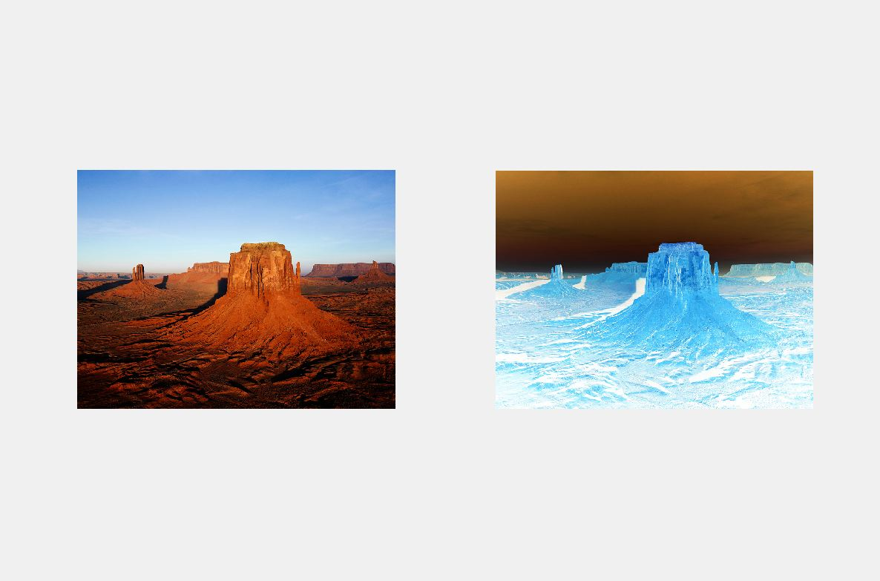

**Program for creating image in MATLAB and complement it:**

X = uint8([ 255 10 75; 44 225 100; 220 20 10]);

subplot(1,2,1);

imshow(X);

X2 = imcomplement(X)

subplot(1,2,2);

imshow(X2);

Output: -

